

Title of the Report
A subtitle (leave empty if none)

Firstname1 Name1
Firstname2 Name2
Course name
Supervised by: Professor Name
September 24, 2026
Aix-Marseille School of Economics • Aix Marseille Université
Master in Economics
Academic Year 2026–2027

Abstract
Write a short summary of your report here (150–250 words): the question, the data, the method, and the main results.
Keywords: keyword 1, keyword 2, keyword 3.

Contents
1 Introduction 1
1.1 Citations 1
1.2 Cross-references 1
1.3 Coloured text 1
2 Figures and Tables 2
2.1 Figures 2
2.2 Tables 2
3 Mathematics 3
4 Boxes 3
4.1 Simple frames 3
4.2 Numbered boxes 4
4.3 Other boxes 4
4.4 Quotes 5
5 Conclusion 5
References 6
A Additional Results 7
B Another Section 7
List of Figures
Figure 1: An example plot. 2
Figure 2: Two panels. 2
Figure B.1: An example plot. 7
List of Tables
Table 1: A nice table. 2
Table 2: Regression results with coloured columns. 3
Table A.1: A nice table. 7

Introduction

Citations
Use a reference manager (Zotero, Mendeley or EndNote) with its Word plug-in, or References › Insert Citation, and choose an author–year style (e.g. Elsevier Harvard or APA). There are several ways of citing a document:
- textual citation: Athey and Imbens (2017) show that…
- parenthetical citation: … as documented in the literature (Athey and Imbens, 2017; Angrist and Pischke, 2009).
- with a page: (Angrist and Pischke, 2009, p. 12).
- with the journal abbreviation: Athey and Imbens (2017, JEP).
With a reference manager, the bibliography is generated automatically and only contains the cited references, e.g. Xie et al. (2018) and Lundberg and Lee (2017).

Cross-references
Sections, figures, tables and equations can be referenced with References › Cross-reference: see Section 2. The reference can include the label automatically: Section 3, Figure 1, Table 1.
Numbers are fields. After editing, select everything (Ctrl+A, Cmd+A on a Mac) and press F9 to update the numbering, the cross-references, the table of contents and the lists of figures and tables.

Coloured text
The colour palette of the slides is available as Word character styles. For every colour, two styles are defined, gras <Name> and highlight <Name>. Select the text and apply the style from Home › Styles (or press Ctrl+Shift+S (or Cmd+Option+Shift+S) and type the name of the style).
Style | Usage | Result
gras <Name> | gras wongOrange | text
highlight <Name> | highlight bleuTOL | text
in an equation | gras roseTOL | $$β_{1}$$
in an equation | highlight wongGreen | $$\hat{θ}$$

A few examples: main colour, alternative colour, emerald, gold, mauve, AMSE blue. Colours can be used inside equations to point at specific terms:
$y_{i}=β_{0}+β_{1}x_{i}+ε_{i}.$ (1)
The full list of colours (Wong, Tol and AMU palettes) is in the Styles pane: all the styles starting with gras or highlight. The AMU colours are also set as the theme colours of the document.

Figures and Tables

Figures
Insert pictures with Insert › Pictures, in a centred paragraph (style Figure), and add the caption below with References › Insert Caption (label Figure). As can be seen in Figure 1, …
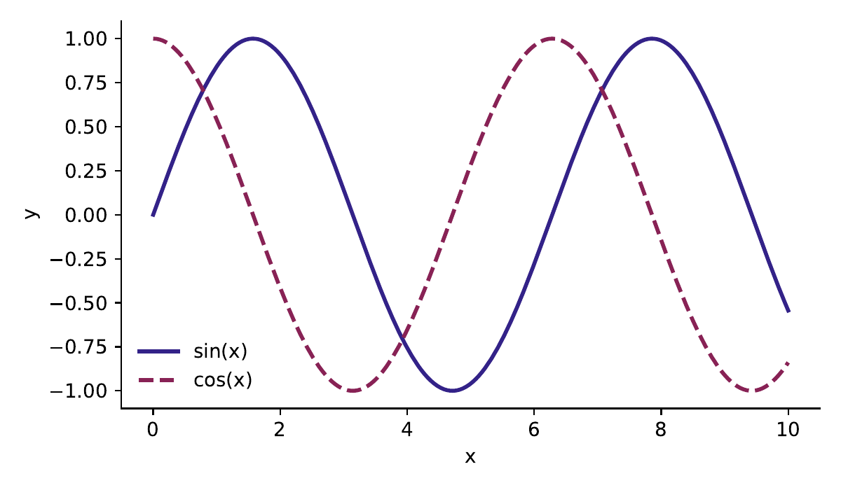
Source: author’s computations. Notes: add notes here.
Figure 1: An example plot.
Two figures side by side (Figure 2a and Figure 2b) are placed in a two-column table without borders:
(a) Left panel. | (b) Right panel.
Figure 2: Two panels.

Tables
As reported in Table 1, … Captions go above tables. Tables use three horizontal rules only (top, below the header, bottom), as with booktabs in LaTeX: apply the table style Booktabs from Table Design.
Table 1: A nice table.
Left-aligned column | Centred column | Right-aligned column
cell 1, row 1 | cell 2, row 1 | cell 3, row 1
cell 1, row 2 | cell 2, row 2 | cell 3, row 2
cell 1, row 3 | cell 2, row 3 | cell 3, row 3
Notes: add footnotes here.
Columns can be coloured with Table Design › Shading and a gras <Name> style for the text, see Table 2.
Table 2: Regression results with coloured columns.
 | (1) OLS | (2) IV | (3) FE
$$x_{1}$$ | 0.512 | 0.634 | 0.489
 | (0.041) | (0.087) | (0.052)
$$x_{2}$$ | −0.120 | −0.098 | −0.131
 | (0.030) | (0.035) | (0.029)
Observations | 1,250 | 1,250 | 1,250

Mathematics
Equations are inserted with Insert › Equation (Alt+=). Word understands LaTeX syntax: in the Equation tab, choose LaTeX and type e.g. \beta_1 or \frac{a}{b}. Inline formula: $E\left[Y∣X\right]=X^{'}β$. Unnumbered displayed equations are centred:
$K\left(x_{i},x_{i'}\right)=\exp\left(-γ\sum_{j=1}^{p}{{\left(x_{ij}-x_{i'j}\right)}^{2}}\right).$
Numbered equations use the paragraph style Equation: Tab, equation, Tab, number. The easiest way is to copy an existing numbered equation.
$φ_{i}=\sum_{S⊆F∖\left\{i\right\}}{\frac{\left|S\right|!\left(\left|F\right|-\left|S\right|-1\right)!}{\left|F\right|!}\left(f_{S∪\left\{i\right\}}\left(x_{S∪\left\{i\right\}}\right)-f_{S}\left(x_{S}\right)\right)},$ (2)
$0=β_{0}+β_{1}x_{1}+β_{2}x_{2}.$ (3)
These equations can then be referred to: Equation (2) gives the Shapley value (Lundberg and Lee, 2017), and Equation (3) a separating hyperplane.
Some usual symbols: $R$, $E$, $P$, $\operatorname{Var}\left(X\right)$, $\operatorname{Cov}\left(X,Y\right)$, $\underset{θ}{argmax}$, $Y\left(1\right)⫫D∣X$, $A⇏B$.

Boxes
Boxes are one-cell tables: copy and paste the box you need, then edit its title and text.

Simple frames
Some coloured frames can be included. Their colours come from the palette of the slides.

Green frame.

Blue frame.

Red frame.

Orange frame.

Numbered boxes
Definitions, propositions and theorems are numbered within sections and are bookmarked, so they can be referenced with References › Cross-reference › Bookmark.
Definition 4.1. Average Treatment Effect
The average treatment effect is $τ=E\left[Y_{i}\left(1\right)-Y_{i}\left(0\right)\right]$.

Proposition 4.1. Unbiasedness
Under random assignment, the difference in means is an unbiased estimator of the ATE defined in Definition 4.1.

Theorem 4.1. Law of large numbers
If $X_{1},…,X_{n}$ are i.i.d. with $E\left|X_{1}\right|<∞$, then ${\overline{X}}_{n}\overset{a.s.}{⟶}E\left[X_{1}\right]$.

Other boxes
Remark. On Proposition 4.1
This result does not hold with self-selection into treatment.

Warning
Correlation does not imply causation.

Example. A randomised experiment
Students are randomly assigned to small or regular classes.

Linearity of expectation
$E\left[aX+bY\right]=aE\left[X\right]+bE\left[Y\right]$.

Question
Does class size affect student achievement?

Athey and Imbens (2017)
A quotation from a paper, in its own box.

Objectives
Estimate the effect of $D$ on $Y$.

Exercise 1
Prove Proposition 4.1.

Important
Keep your report short. Do not let any AI write long and boring sentences. Nobody wants to read long and meaningless paragraphs in a report.

Quotes
“All models are wrong, but some are useful.”
George Box (1979)
An inline quotation: “a short quotation” (style Inline quote).

Conclusion
Summarise your main findings, their limits, and possible extensions.
References
Angrist, J.D., Pischke, J.S., 2009. Mostly Harmless Econometrics: An Empiricist’s Companion. Princeton University Press, Princeton. doi:10.1515/9781400829828.
Athey, S., Imbens, G.W., 2017. The state of applied econometrics: Causality and policy evaluation. Journal of Economic Perspectives 31, 3–32. doi:10.1257/jep.31.2.3.
Lundberg, S.M., Lee, S.I., 2017. A unified approach to interpreting model predictions. Advances in Neural Information Processing Systems 30, 4765–4774.
Xie, Y., Allaire, J.J., Grolemund, G., 2018. R Markdown: The Definitive Guide. Chapman and Hall/CRC, Boca Raton, Florida. https://bookdown.org/yihui/rmarkdown.

Additional Results
Appendix sections are numbered A, B, C… The numbering of tables and figures follows the appendix letter (Table A.1, Figure B.1). To insert such a caption, tick Include chapter number in Insert Caption › Numbering.
Table A.1: A nice table.
Left-aligned column | Centred column | Right-aligned column
cell 1, row 1 | cell 2, row 1 | cell 3, row 1
cell 1, row 2 | cell 2, row 2 | cell 3, row 2
cell 1, row 3 | cell 2, row 3 | cell 3, row 3
Notes: add footnotes here.

Another Section
Source: author’s computations. Notes: add notes here.
Figure B.1: An example plot.

